Barangaroo South
Code of practice
customer complaint handling

Contents

Introduction 3
Background 3
Purpose 4
Scope 5
Reference Standard 5
Customer Service 6
Customer Service Operating Model 7
Appendix 1 - Customer Complaints Process 9
Appendix 2 – Debt Recovery 13

Introduction
Customer management is a complex activity across Lendlease with a number of projects that undertake a pre-defined project completion approach aligned with customer expectations.

With the creation of Podium Asset Services (formerly Living Utilities) as Lendlease’s private utility company, the duration and frequency of customer management is significantly more intensive in effort. In comparison to the pre-defined engagement cycles from other Lendlease businesses, Podium Asset Services will have a significantly longer engagement cycle in comparison to other business units at Lendlease. The purpose of this document is to capture the processes and approaches to help Podium Asset Services manage customers across their engagement cycles.

Background
Barangaroo South is part of a larger Barangaroo regeneration project established to make Sydney the leading financial hub within Australia. The precinct includes over 75 retail experiences, in excess of 100 floors of office space at International Towers Sydney (ITS), a promenade connecting 14 kilometres of the harbour foreshore and beautiful residential apartments.
The precinct is aiming to be water positive, with an on-site, blackwater treatment plant capable of supplying one million litres of recycled water a day to the precinct and surrounding area, and by 2020, Barangaroo is targeting zero net waste to landfill. Currently, Barangaroo South has a 6 Star Green Star Community Rating indicating the commitment to sustainability and renewability across the precinct.
To achieve these goals, Barangaroo infrastructure developed and implemented by the Authority and the site's developers across the whole district includes:
- a recycled water plant that provides recycled water and sewerage services
- a chilled water and harbour cooling system, recycled water service and waste recycling service
- an embedded network (‘poles and wires’) to help retail service providers connect customers to the electricity network
The collective name given to these utilities is Lend Lease Green Utilities (LLGU). Throughout this document, the following naming convention will refer to the three utilities that Podium Asset Services is managing across the precinct.

Purpose
This code of practice provides a guideline for complaint handling by management and employees of:

- Lendlease Recycled Water (Barangaroo South) Pty Limited in relation to its recycled water, wastewater and trade waste services
- Lendlease Chilled Water (Barangaroo South) Pty Limited in relation to its chilled water supply services
- Lendlease Embedded Network (Barangaroo South) Pty Limited in relation to its network charges to the electrical retailers
- Operators of the Networks

For ease, each entity nominated above will be known as Lend Lease Green Utilities (LLGU) now operated by Podium Asset Services PAS (formerly Living Utilities).

This code of practice is for LLGU/PAS internal use only. A short version shall be made available to Customers and to the general the public on the Podium Asset Services website and shall be included as part of Customer Contracts.

Scope
LLGU own and operate the central infrastructure on the Barangaroo South precinct. As part of the operations LLGU and its entities have a series of supply agreements with its customers and electrical retailers.

In most cases our entities enter into separate Operator agreements of the networks, as such Lend lease Green Utilities and its specialist Operators each commit to provide these services in accordance with this code of practice. LLGU and its Operator will share responsibility for customer communication, complaints handling and debt recovery. The split of responsibility is as follows:

- LLGU - All financial related customer interface matters including tariff setting and debt recovery
- Utility Operator - All operational related customer interface matters

This policy applies to all complaints from customers or other members of the community received by LLGU or its Operators.

Reference Standard
This code of practice conforms to and takes from AS/ISO 10002—2006 Customer Satisfaction; Guidelines for complaints handling in organisations, as published by Standards Australia.

Customer Service
LLGU/PAS has selected Serviceworks Management as a single point of customer service for all customers. Serviceworks will support LLGU/PAS in managing customer complaints and concerns as they interact with Barangaroo South Green Utilities.

Customer Service Operating Model
This section outlines the overall operating model through which LLGU plans to engage with its customers, service providers, and applicable Lendlease business units in the delivery of LLGU to customers. The diagram on the following page demonstrates how the customer service operating model operates. In the design of the overall model, it was important to ensure that feedback loops existed amongst the key participants (Serviceworks Management, Retail Service Providers, Veolia, and LLGU/PAS) to streamline the customer resolution process.

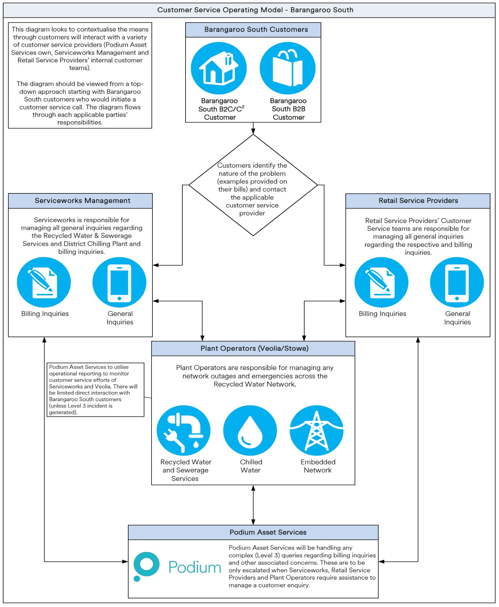
Figure 1 Customer Service Operating Model (End-State)

Escalation Approach
Podium Asset Services will utilise a 3-tier escalation approach to handle customer service enquiries. This system aligns with agreements around customer service with Serviceworks Management to handle customer service issues for LLGU.

The table below outlines the overall responsibilities that will be handled by the following entities (Serviceworks Management, Veolia and Podium Asset Services):
Escalation Level | Description | Types of Incidents | Resolution Provider
Level 1 | Focuses on managing basic requests from customers regarding their accounts and basic billing inquiries | Bill amounts, basic account setup, customer verification, general queries, how to connect to the meter | - Serviceworks Management  - Veolia (where applicable)
Level 2 | Focuses on handling billing queries for established customers | Billing amounts, disputes with Green Utilities (Recycled Water, and Chilled Water), customer change of address, targeted queries around Green Utilities, metering issues, billing amounts | - Serviceworks Management  - Veolia (where applicable)  - Retail Service Providers (where applicable)
Level 3 | Focused on commercial issues with Green Utilities around billing, water pressure, billing variances, meters and other issues | Missing billing periods, issues with pressure across multiple properties, issues with LLGU, plant visibility and other associated issues | - LLGU/PAS  - Serviceworks Management (where applicable)  - Veolia (where applicable)  - Retail Service Providers (where applicable)

As indicated above, the Level 3 issues will be escalated to LLGU/PAS; however, this will only occur when Level 2 and Level 1 escalations have happened. Once Level 3 issues have been identified to PAS, senior management at PAS will retain ownership of the issue and look to coordinate with applicable parties and resolve the issue as needed.

Appendix 1 - Customer Complaints Process

Code of practice
customer complaint handling

LLGU/PAS and its Operators share common corporate goals of Customer Focus. LLGU/PAS, and its partners, are committed to Customer Service Excellence including handling Customer complaints in relation to service, technical and financial matters. Assuring customers of this commitment, LLGU/PAS and Operators have agreed to the following Customer Complaints process:

Customer Complaints Process Resolution
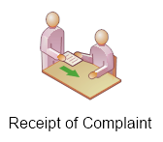  1 | Receipt of complaints  Upon receiving a complaint, the complaint will be recorded with supporting information and a unique identifier code given to the customer (Appendix 1). The record of the initial complaint will identify the remedy sought by the complainant and any other information necessary for the effective handling of the complaint. LLGU aims to resolve customer complaints at the first point of contact by providing a solution or negotiating an agreed course of action.
2 | Tracking of complaints  The complaint will be tracked from initial receipt through the entire process until the complainant is satisfied or the final decision is made. An up-to-date status will be made available to the complainant upon request and at regular intervals.  Initial assessment of complaint  After receipt, each complaint will be initially assessed in terms of criteria such as severity, safety implication, complexity, impact, and the need and possibility of immediate action.  Investigation of complaints  Every reasonable effort will be made to investigate all the relevant circumstances and information surrounding a complaint. The level of investigation will be commensurate with the seriousness, frequency of occurrence and severity of the complaint.
3 | Response to complaints  If it is not possible to resolve the complaint immediately, will provide an initial response within:  - 2 working days if the complainant has phoned or spoken directly to us, or  - 5 working days if the complainant has written or sent an email and the matter cannot be responded to sooner by making contact with the complainant.  Initial responses can be:  - a solution presented to, and accepted by, the complainant or  - intended course of action to resolve the complaint.  If the complaint cannot be resolved to the complainant’s satisfaction, it will be escalated to the next level of management for resolution. Following an appropriate investigation, the applicable customer service provider will offer a response, for example correct the problem and prevent it happening in the future. If the complaint cannot be immediately resolved, then it will be dealt with in a manner intended to lead to its effective resolution wherever possible.
4 | Communicating the decision  The decision or any action taken regarding the complaint, which is relevant to the complainant or to the personnel involved, will be communicated to them as soon as the decision or action is taken.  Closing the complaint  If the complainant accepts the proposed decision or action, then the decision or action will be carried out and recorded. If the complainant rejects the proposed decision or action, then the complaint will remain open. We will continue to monitor the progress of the complaint until all reasonable internal and external options of recourse are exhausted or the complainant is satisfied
5 | Lessons Learned  LLGU and its Operator will regularly review all complaints received and identify where improvements may be achieved to ensure the highest level of Customer Satisfaction.
6 | LLGU and its Operator will, where identified through its review process:  - Design and develop training  - Review corporate Policy and Codes of Practice  - Review communication techniques
Recourse to further action
In the event a customer is not satisfied with the handling of their complaint, they will be advised of their right to raise their concerns with the Energy and Water Ombudsman of NSW (EWON) for external review. This option is also available to the customer at any time after first lodging their complaint with LLGU.
Contact EWON on 1800 246 545 or at www.ewon.com.au

Appendix 2 – Debt Recovery
Code of practice
Debt Recovery

Purpose
This code of practice provides a guideline for debt recovery by management and employees of;

- Lendlease Recycled Water (Barangaroo South) Pty Limited in relation to its Recycled water, potable water and trade waste services
- Lendlease Chilled Water (Barangaroo South) Pty Limited in relation to its Chilled water supply services
- Lendlease Embedded Network (Barangaroo South) Pty Limited in relation to its network charges to the electrical retailers

For ease, each entity nominated above will be known as Lend Lease Green Utilities (LLGU) now operated by Podium Asset Services (formerly Living Utilities).

This code of practice is for LLGU internal use only. A shorter version shall be made available to Customers and to the general the public and shall be included as part of Customer Contracts.

Background
LLGU own and operate the central infrastructure on the Barangaroo South precinct. As part of the operations LLGU and its entities have a series of supply agreements with its customers and electrical retailers.

In most cases our entities enter into separate Operator agreements of the networks, as such LLGU and its specialist Operators each commit to provide these services in accordance with this code of practice. LLGU and its Operator will share responsibility for customer communication, complaints handling and debt recovery. The split of responsibility is as follows:

- LLGU - All financial related customer interface matters including tariff setting and debt recovery
- Utility Operator - All operational related customer interface matters

This policy applies to all complaints from customers or other members of the community received by LLGU or its Operators.

Licence Holder Obligation

Included
Pursuant to the above Regulation, LLGU shall:
- establish and comply with this code of practice for debt recovery
- provide copies of this code of practice to the Minister, IPART and to the Ombudsman (EWON), and
- keep its customers informed as to the provisions of this code of practice.

Not Included
This code of practice applies to persons that have a small retail customer (body corporates / householders) contract with LLGU for Trade Waste services, Recycled and/or Potable Water supply services and does not apply to tenants of customers (without derogating tenants ‘rights under law). This code also generally applies to large customers (e.g. Commercial Office Tower).

Guiding Principles
This code of practice conforms to and takes from ACCC and ASIC Debt Collection Guideline: for collectors and creditors as published by the ACCC and ASIC in October 2005 and reprinted in April 2010.

Notably the ACCC/ASIC guideline is specifically developed for Debt Collection Agencies whereas this code of practice is for reference by LLGU appointed personnel for handling debt recovery by LLGU. Only when this code of practice is followed through to completion and debt remains shall LLGU transfer debt recovery to a third party debt Collection Company.

Practical Guidance

Contact for a reasonable purpose only
Communications with the debtor must always be for a reasonable purpose, and should only occur to the extent necessary. It is considered necessary and reasonable for LLGU to contact a debtor to:

- give information about the debtor ‘s account
- convey a demand for payment
- accurately explain the consequences of non-payment, including any legal remedies available to the collector/creditor, and any service restrictions
- make arrangements for repayment of a debt
- put a settlement proposal or alternative payment arrangement to the debtor
- review existing arrangements after an agreed period
- ascertain why earlier attempts to contact the debtor have not been responded to within a reasonable period, if this is the case. and
- ascertain why an agreed repayment arrangement has not been complied with, if this is the case

Making contact with the debtor
Under privacy laws, LLGU has an obligation to protect the privacy of debtors. When making direct contact, we must always ensure the person we are dealing with is the debtor. This must be done every time we make contact before you divulge any information about the debt, the process for its recovery or other confidential information.

The privacy limits on disclosing information to third parties apply to the debtor ‘s spouse, partner and/or family as much as they apply to other third parties. Having established the debtor ‘s identity, you should then identify who you are and whom you work for and explain the purpose of the contact.

We identify ourselves only by company name and enquirers first name and also give at least basic information about the debt, including the name of the creditor and any assignee of the debt, and details of the account and the amount claimed.

Hours of contact
We only contact the debtor or a third party at reasonable hours, taking into account their circumstances and reasonable wishes. The following are considered reasonable:

Contact Method | Periods | Times
By Phone, emails and fax | Monday to Friday | 7.30am – 9.00pm
 | Weekends | 9.00am – 3.00pm
 | Public Holidays | Nil
Face-to-Face (not by LLGU ; by third party collector only | Monday to Friday  Weekends | 9.00am – 9.00pm  9.00am – 3.00pm
engaged by LLLU | Public Holidays | Nil

There may be reasons why contact during the above times is unreasonable or contact outside of these times is reasonable. For instance, a debtor may ask that contact be made at other or more restricted times. This may be for a range of reasons including but not limited to debtor is a shift worker, or is responsible for children and contact around meal times is not convenient or debtor does not wish to be contacted when other family members are present or other.

In these and other such cases, the reasonable wishes of the debtor should be respected, and contact limited to the times requested by the debtor. However, we may alter the time of contact if, after reasonable efforts over a reasonable period of time to contact the debtor during normal hours or at the times requested by the debtor, if we have not been able to do so.

Frequency of contact
Debtors are entitled to be free from excessive communications from collectors. Communications must always be for a reasonable purpose and should only occur to the extent necessary.

Unduly frequent contact designed to wear down or exhaust a debtor, or likely to have this effect, constitutes ‘undue harassment’ or coercion and is contrary to this code of practice. This is particularly likely if a number of phone calls or other contacts are made in rapid succession.

Location of contact
In most cases, the debtor’s home will be the appropriate place to contact a debtor, with contact by letter or telephone generally being the appropriate mode of contact. However, if a debtor provides a telephone (including mobile phone) contact number as the means of contact, contact using that number will be appropriate whatever the debtor’s location.

Sometimes, a debtor may not wish to be contacted at their home. If the debtor provides an alternative and reasonable location for contact and is able to be contacted at that location, the debtor should not be contacted at home.

Privacy obligations to the debtor
A debtor’s personal information should always be treated with respect. The improper use of a debtor’s personal information may cause that person serious difficulties. There are legal obligations under the NSW Privacy Act 1988 designed to protect the privacy of a debtor’s personal information.

When a debtor is represented
A debtor has a right to have an authorised representative (such as a financial counsellor, financial advisor, community worker, solicitor, guardian or carer) represent them or advocate on their behalf about a debt. Except in the circumstances outlined below LLGU shall not contact a debtor directly after we know, or should know, that the debtor is represented and shall not refuse to deal with an appointed or authorised representative. LLGU is entitled to contact a debtor directly if:

- the representative does not respond to within a reasonable time (normally 14 days)
- the representative advises that they do not have instructions from the debtor about the debt
- the representative does not consent to act
- the debtor specifically requests direct communication with you
- the representative is not a solicitor and you advise that written authority stating that you are to communicate through the debtor’s representative is required, and the debtor or their representative does not provide that authority.

Record keeping
Accurate record keeping by all parties is vital to promptly resolve disputes and allow collectors and debtors to limit or avoid costly collection activity. LLGU shall ensure:

- we maintain accurate, complete and up-to-date records of all communications with debtors, including the time, date and nature of calls about the debt, records of any visits in person, and records of all correspondence sent
- all payments made are accurately recorded (including details of date, amount and payment method).
- settlements are fully documented in relevant files and computer systems
- once a debt is settled, any credit reporting agency report on the debtor must be updated appropriately

Providing information and documents
Requests by debtors for information and/or documentation about an account should not be ignored. In certain circumstances, failure to provide information may constitute misleading and deceptive conduct or unconscionable conduct. LLGU shall provide such information as necessary to demonstrate proof of debt.

If liability is disputed
If a person LLGU contacts about a debt claims that they are not the alleged debtor or the debt has been paid or otherwise settled and we have not already confirmed their identity and liability, we shall suspend further collection activity (including credit report listing) until the debtor’s identity and ongoing liability have been confirmed.

Conduct towards the debtor
A debtor is entitled to respect and courtesy, and must not be subject too misleading, humiliating or intimidating conduct. Such conduct is likely to breach the Commonwealth consumer protection laws and may breach other laws as well.

Customers Suffering Financial Hardship

LLGU commitment
This code of practice provides for the deferment, in whole or in part, of payments owed by retail customers suffering financial hardship. In such cases of financial hardship LLGU shall not enforce disconnection of services in part or in whole.

Debtors
Debtors are legally responsible for paying the debts they legitimately owe, and they should not deliberately try to avoid their obligations. Whenever possible, debtors should take action before they get into difficulties. Debtors experiencing financial hardship should promptly contact LLGU to negotiate a variation in payments or other arrangement. In seeking a variation, debtors should be candid about their financial position, including their other debts. LLGU also recommends that debtors in financial difficulty consider seeking the assistance of a community-based financial counsellor, solicitor or other qualified adviser who may be able to help them with a debt negotiation.

Hardship
Proof of financial hardship shall be provided by the relevant customer. Examples of hardship may include but not be limited to:

- Loss of employment
- Low income constraints
- Pensioner (age, disability or other) budget constraints
- Commercial difficulties (businesses)
- other (undefined)

Assistance
Assistance may include one or more of the following:

- Deferrment of payment for an agreed period of time
- Incremental instalments to recover the debt over time
- Regular smaller payments spread over time to assist budgeting by customers exposed to hardship.

Waiver
Notwithstanding the above commitment, LLGU having taken all steps reasonably practicable in accordance with this code of practice and the customer contract to recover debt and that debt still not paid by the customer may take such further actions as allowable to it in law to recover such debt but not disconnection of services to residential and other small retail customers, nor reduce the flow of non-potable water below necessary for basic hygiene or restrict the flow of sewage into the main.

Maintenance and Improvement

Collection of information
LLGU shall record the performance of its debt recovery handling process. LLGU shall establish and implement procedures for recording debt and for using these records and managing them, while protecting any personal information and ensuring the confidentiality of complainants. This shall include the following:

- specifying steps for identifying, gathering, classifying, maintaining, storing and disposing of records;
- recording its handling of debt recovery and maintaining these records, taking utmost care to preserve such items as electronic files and magnetic recording media, since records in these media can be lost as a result of mishandling or obsolescence;
- keeping records of the type of training and instruction that individuals involved in the debt recovery process have received;
- specifying LLGU’s criteria for responding to requests for record presentation and record submissions made by a debtor or his or her agent; this may include time limits, what kind of information will be provided, to whom, or in what format;
- specifying how and when statistical non-personally identifiable debt data are disclosed to the public.

Analysis and evaluation of debt
All debt shall be classified and then analysed to identify systematic, recurring and single incident problems and trends, and to help eliminate the underlying causes of debt.

Monitoring of the debt recovery process
Continual monitoring of the debt recovery process, the resources required (including personnel) and the data to be collected shall be undertaken. The performance of the debt recovery process shall be measured against predetermined criteria.

Auditing of the debt recovery process
LLGU shall regularly perform or provide for audits of both LLGU and/or its Operators in order to evaluate the performance of the debt recovery process. The audit shall provide information on
- process conformity to debt recovery procedures, and
- process suitability to achieve debt recovery objectives.

The debt recovery audit may be conducted as part of LLGU quality management system audit. The audit results shall be taken into account in the management review to identify problems and introduce improvements in the debt recovery process. The audit shall be carried out by competent individuals independent of the activity being audited.

Management review of the debt recovery process
Senior management of LLGU shall review the debt recovery process on a regular basis in order
- to ensure its continuing suitability, adequacy, effectiveness and efficiency
- to identify and address instances of nonconformity with health, safety, environmental, customer, regulatory and other legal requirements
- to identify and correct product deficiencies
- to identify and correct process deficiencies
- to assess opportunities for improvement and the need for changes to the complaints handling process and products offered, and
- to evaluate potential changes to the complaints handling policy and objectives.

Records from any management review shall be maintained and used to identify opportunities for improvement.

Continual improvement
LLGU shall continually improve the effectiveness and efficiency of the debt recovery process. As a result, LLGU can continually improve the quality of its products. This can be achieved through corrective and preventive actions and innovative improvements. LLGU shall take action to eliminate the causes of existing and potential problems leading to customer debt in order to prevent recurrence and occurrence, respectively.

Debtor Disputes and Complaints Handling
In the event a customer has a compliant regarding the handling of their debt by LLGU , we shall direct the customer to our complaints handling system.

Dependent of the complaint and in the event a customer is not satisfied with the handling of their complaint by LLGU, we shall direct the customer to the Energy and Water Ombudsman of NSW (EWON) should they wish to take further action.

REFERENCE DOCUMENTS (to be prepared)

- Debt Recovery Policy
- Code of Practice for inclusion in Customer Contracts
- Debt Recovery Organisation and Responsibilities
- Debt Recovery Procedure
- Debt Recovery Administration Procedure
- Performance Monitoring - Key Performance Indicators (KPIs)
- Training Program
- Audit outline how LLGU responds to overdue water bills and recovers outstanding payments.

